FINALS TASK 5. Designing a Tkinter Window and adding events
PART 1. Grading PROGRAM
1. Design the window below.
2. The program should allow the user to input Prelim, Midterm, Pre Finals and Final Grade (Compute GPA by adding the Prelim, Midterms, (50% of Pre-Finals and 50% of the Final Grade) then divide by 3) 3. The user should be able to select which equivalent grade to view using Combo Box: (Letter Grade or NUMERIC GRADE)
4. Compute Button should compute the GPA and display the appropriate grade equivalent and other info in a Textarea (Text) as shown in the sample output
5. The Reset Button should clear the Radio Button Selection and the Text field entries should be cleared as well
6. The About button should display a dialog with the message: “Hello I’m your Name” 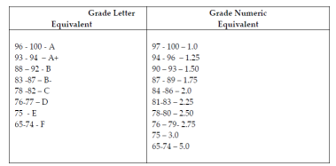
Follow this table of equivalents for LETTER and NUMERIC GRADE
Sample GUI Design below:
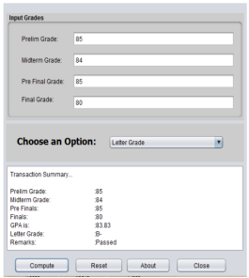
^{Note:}Use appropriate containers and layout managers as you deem necessary and widgets as shown.
Rubrics:
Rubrics: Form Design and Layout : 10 points
Program Correctness : 40 points (Reset – 5 pts., About – 5 pts. , Compute – 30 pts.)

